# Homework #5: Active Directory and Group Policy Objects

|  |
| --- |
| * This is an individual assignment, and is worth 20 points. * The due date is Monday, March 8, 2021. * You need to provide your answers to the “Homework #5 – Tasks.docx” file. Change the file name following the naming convention suggested below. * Naming convention is as follows: homework, underscore, last name, first initial, and extension (e.g., Homework #5_ImG.docx). * If you do not zoom in your screenshots, I will penalize you. |

* (**Task 1**) Show in a screenshot that the three domain users (sqluser1, sqluser2, sqluser3) are created in **SQLUsers** OU. Also show in a screenshot that **sqlgroup** is created in the **Groups** OU.

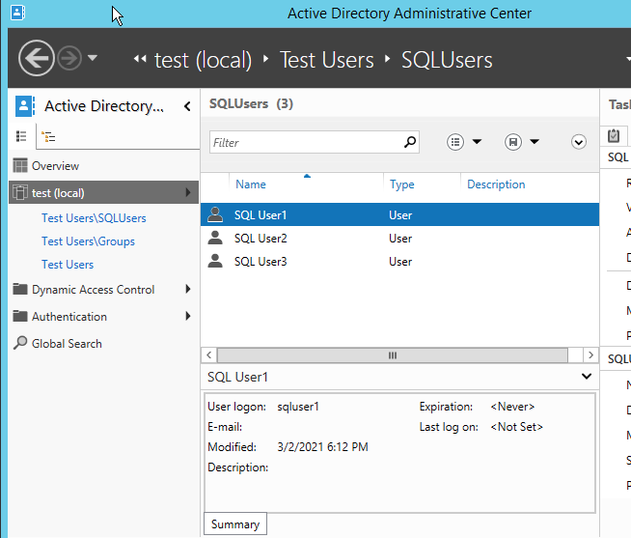

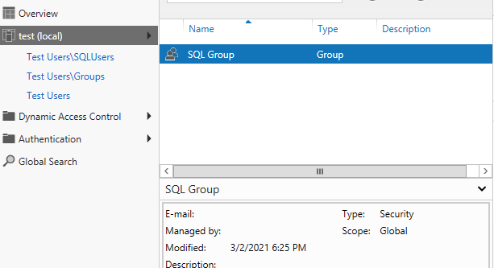

* (**Task 2**) Go to sqluser1 properties and show in a screenshot that sqluser1 is a member of **Domain Admins** and **sqlgroup**.

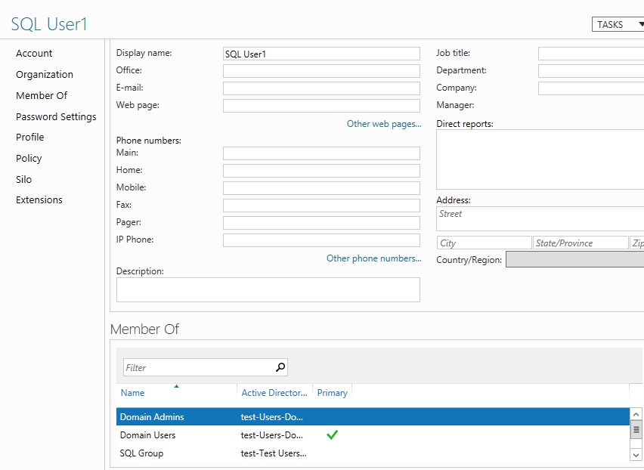

* (**Task 3**) Run the following query on SQL Server and show in a screenshot that you indeed logged-on with sqluser1.

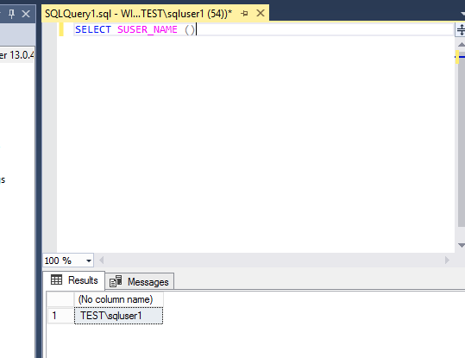

* (**Task 4**) Logon to SQL Server. Create a login “**Cardinal1**”. Select **SQL Server authentication**. Enter the password “1234567”, and show in a screenshot that the login cannot be created. Explain why?

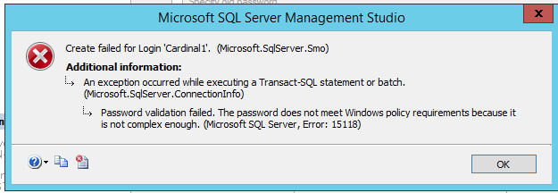

The user cannot be created because it does not meet the policy requirement that was enforced. For example, a letter, upper case letter, and even special characters can be in the policy, what was included is just numbers 1 through 7.

* (**Task 5**) Create a login “**Cardinal1**”. Select **SQL Server authentication**. Enter the password “1234567”, and show in a screenshot that the login is created. Explain why this was possible. Explain also the relationship between the GPO and the SQL Server password policy.

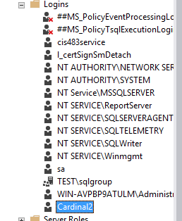

The user account Cardinal2 was created with password 1 through 7, the reason it was created with this password is because I have disabled the policy requirement, thus any password would have worked. GPO and SQL Server password policy is that a GPO defines the settings for a specific group user such as test.ad that we had, So anything within the test.ad would no longer requires a secured complex password. SQL server password policy is standard for the entire of SQL server.

* (**Task 6**) Create a new AD account using the command **New-ADUser** explained on pp 12-13. Show in a screenshot that the account is indeed created (example below). Also, attach a screenshot that displays the PowerShell execution.

